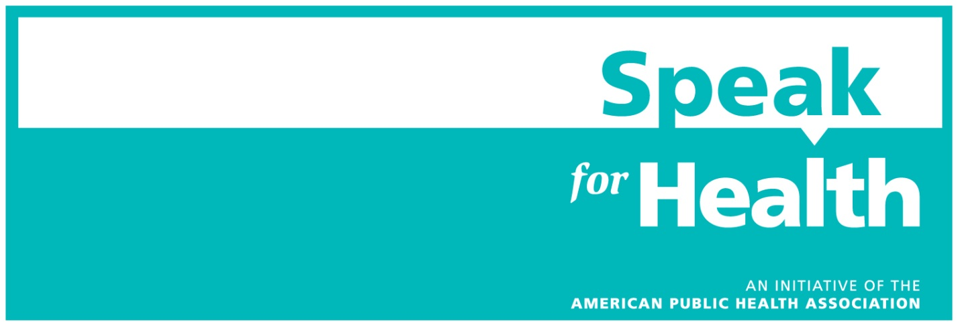

Want to help APHA spread the word and encourage your community to vote for representatives who champion public health? Fill in the missing information (those sections are highlighted in yellow) in this op-ed and tell others why you’re voting for candidates who support public health. The template op-ed also links to the Public Health on the Ballot quiz, so others in your community have the tools to ask the right questions and evaluate candidates for themselves.
Use APHA’s state fact sheets to learn more about the public health challenges your state is facing and include that information in the op-ed below.
For tips on how to submit an op-ed to your local newspaper, check out this resource from The Op-Ed Project.
Be careful that you do not represent the views in the op-ed letter as being the views of American Public Health Association, which as a 501(c)(3) organization, cannot comment on specific candidates.
TEMPLATE OP-ED

[INSERT STATE/COMMUNITY] needs a public health champion
Our state is in need of public health champions now more than ever. Our community is burdened by [insert a few public health issues that are important to your state here. For example, the opioid epidemic, rising health care costs, the spread of STDs, gun violence, obesity or poor nutrition, air pollution, etc.]
As [insert state/community] prepares to elect a new [Representative/Senator/Senators], it’s time for us to find a leader who can help us tackle these problems. We need public health champions who can bring our concerns to Congress and be a hardworking advocate for [insert state/community]’s health.
Polls say health is the No. 1 issue for most voters in this election, but how are we supposed to make sure a candidate will put our health first? Let’s start by asking the right questions before we cast our ballot.
Will [insert name of candidate] protect and support the Affordable Care Act? Does [insert name of other candidate] have a plan to keep our community safe and healthy in the face of climate change? Will [he/she] support funding for more research and programs so we have a well-equipped public health workforce in [insert state/community] that’s ready to meet health challenges tomorrow, next year or 10 years from now? How will [he/she] do this?
If we don’t ask these questions now, we won’t know how our elected officials will vote on issues like stopping the opioid epidemic and improving health insurance when they get to Washington, D.C. As we say in public health, an ounce of prevention is worth a pound of cure. Let’s make sure we’re asking the right questions now.
Public health runs across party lines. Illness and disease don’t understand political alliances. This isn’t about politics. This election, for [insert state/community], is about protecting our families and communities and planning for a healthier future.
I encourage anyone who wants to make sure they’re voting for a public health champion to take this quiz from the American Public Health Association. It helps voters evaluate their candidate’s position on important public health issues like supporting families and women, the Affordable Care Act and opioids. Or, bring this checklist to a town hall or meeting with a candidate and ask them these questions face-to-face.
[Insert city/community] deserves representatives who will fight for our health. By asking the right questions, we can make public health a priority in our community and in Washington, D.C.
The opinions of the writer on the candidates are solely his/her views and do not represent the views of American Public Health Association, which cannot comment on any of the candidates.

