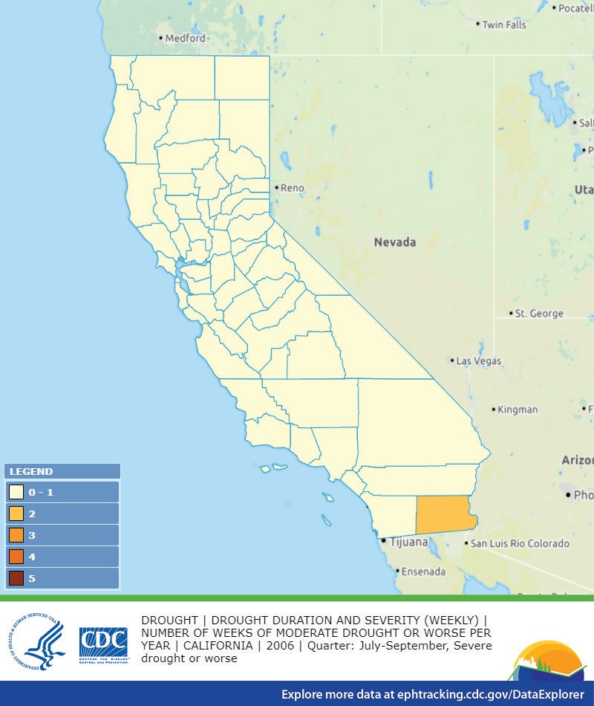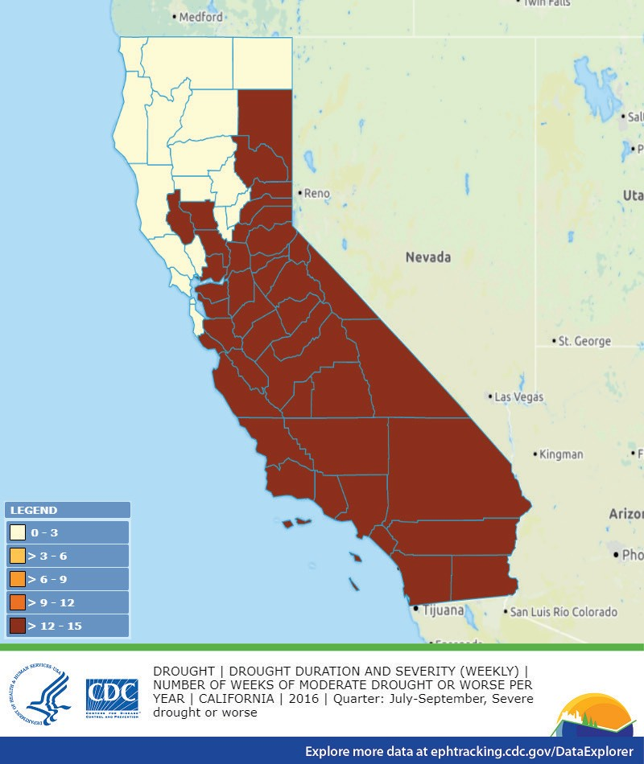

**California**

**CLIMATE AND HEALTH**

**BACKGROUND**

Burning fossil fuels, such as coal and gas, releases carbon dioxide. CO2 builds up in the atmosphere and causes Earth’s temperatures to rise. This extra, trapped heat disrupts many of the interconnected systems in our environment, posing risks to human health. Some impacts of climate change are already being felt throughout the United States. We need to safeguard our communities by protecting people’s health from the effects of climate change.

**ISSUE SUMMARIES**

**DROUGHT AND WILDFIRES**

Droughts increase the likelihood of health hazards like wildfires, dust storms, extreme heat events, flash floods and degraded air and water quality. Drought threatens water supplies and ecosystems, contributing to increased food prices that disproportionately affect low-income individuals. Exposure to wildfire smoke and dust storms increases respiratory and cardiovascular hospitalizations, asthma, bronchitis, chronic obstructive pulmonary disease and

medical visits for lung illnesses and respiratory infections.

**CALIFORNIA DROUGHT, 2006**

**CALIFORNIA DROUGHT, 2016**

*Source: The Centers for Disease Control and Prevention*

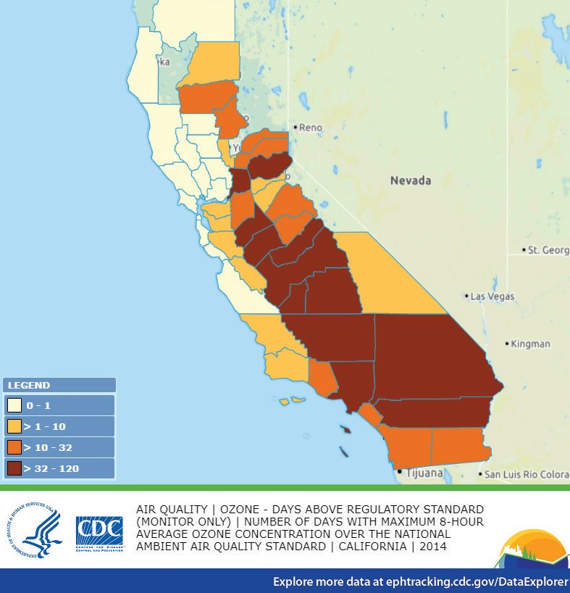

**AIR POLLUTION**

Climate change is increasing ground-level ozone and other types

of air pollution. Smog, air toxics, particulate matter and climate-

changing gases such as CO harm health. Smog makes it hard

2

to breathe and worsens certain health conditions. Air toxics and particulate matter can cause increased hospitalizations, asthma, bronchitis, heart attacks, chronic obstructive pulmonary disease

and premature death.

**NUMBER OF DAYS ABOVE OZONE REGULATORY STANDARD, 2014**

*Source: The Centers for Disease Control and Prevention*

**EXTREME HEAT**

Extreme heat leads to increased hospitalizations and, sometimes, fatal health events. Children, the elderly, people with chronic diseases, low-income populations and outdoor workers are at the highest risk for heat-related illnesses. Extreme heat is also linked to increased aggression, raising the incidence of assaults,

murders and suicides.

[**www.apha.org/climate**](http://www.apha.org/climate)

**#ClimateChangesHealth**

**FAST FACTS**

**California averages 35 dangerous heat days per year.** By 2050, it is projected to increase to almost 50 days per year.

**California has 8 of 10 of the most polluted cities** and the worst air quality in the U.S., causing respiratory illnesses.

**Over 1 million Californians** are categorized as especially vulnerable to extreme heat events

**Los Angeles residents**

**O were exposed to**

**3 unhealthy levels of**

**ozone** for 91 days in 2014.

Current and past climate action progress in **California prevents about 5,000 premature deaths each year.**